https://developer.mozilla.org/en-US/docs/Learn/HTML/Introduction_to_HTML/Structuring_a_page_of_content:

Structuring a page of content

Heading 1

Heading 2

Heading 3

Heading 4

Heading 5

Structuring a page of content ready for laying it out using CSS is a very important skill to master, so in this assessment you'll be tested on your ability to think about how a page might end up looking, and choose appropriate structural semantics to build a layout on top of.
Prerequisites: | Before attempting this assessment you should have already worked through the rest of the course, with a particular emphasis on Document and website structure.
Objective: | To test knowledge of web page structures, and how to represent a prospective layout design in markup

Starting Point
To get this assessment started, you should go and grab the zip file containing all the starting assets. The zip file contains:
- The HTML you need to add structural markup to.
- CSS to style your markup.
- Images that are used on the page.
Create the example on your local computer, or alternatively use a site like JSBin or Thimble to do your assessment.

Project Brief
For this project, your task is to take the content for the homepage of a bird watching website and add structural elements to it so it can have a page layout applied to it. It needs to have:
- A header spanning the full width of the site containing the main title for the page, the site logo, and the navigation menu. The title and logo appear side by side once styling is applied, and the navigation appears below those two items.
- A main content area containing two columns — a main block to contain the welcome text, and a sidebar to contain image thumbnails.
- A footer containing copyright information and credits.
You need to add a suitable wrapper for:
- The header
- The navigation menu
- The main content
- The welcome text
- The image sidebar
- The footer
You should also:
- Apply the provided CSS to the page by adding another <link> element just below the existing one provided at the start.

Example
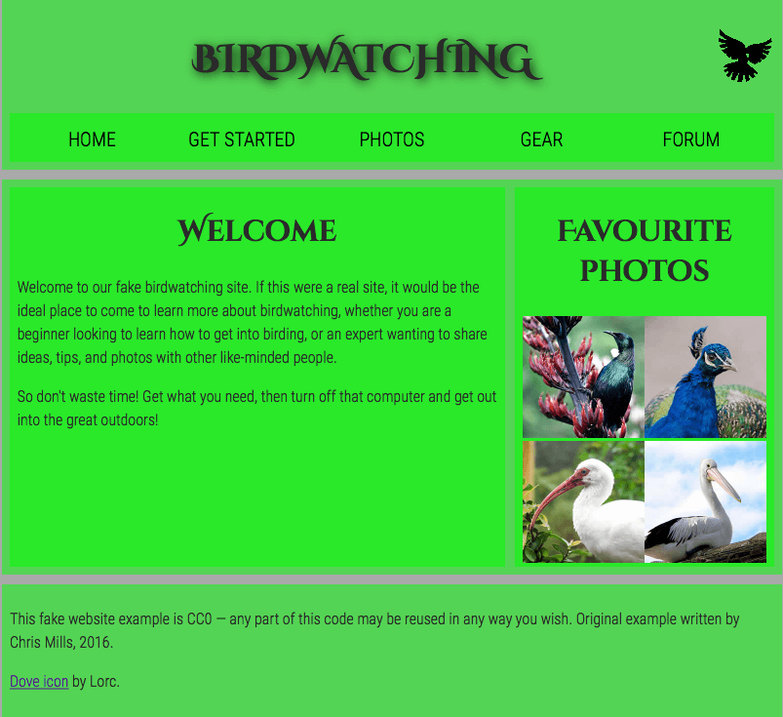

Assessment
If you are following this assessment as part of an organized course, you should be able to give your work to your teacher/mentor for marking. If you are self-learning, then you can get the marking guide fairly easily by asking on the Learning Area Discourse thread, or in the #mdn IRC channel on Mozilla IRC. Try the exercise first — there is nothing to be gained by cheating!

